
FURTHER MATHEMATICS
TRIAL EXAMINATION 2
SOLUTIONS
2010

SECTION A

Core - solutions

Question 1

- The distribution is negatively skewed.
(1 mark)

- The median is found at the 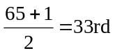position counting in from either end. Median water consumption lies in the interval 1100L – 1200L.
(1 mark)

- 13 households use between 700L and 1000L of water per day.
This represents 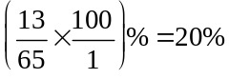
(1 mark)

Question 2

- 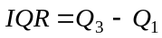
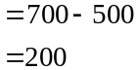
(1 mark)

- The bottom 25% of households with large tank capacity have an average daily town water consumption of between 140L and 200L per day.
(1 mark)

- The median town water consumption increases as tank capacity decreases.
(1 mark)
Question 3

- There are ten points. Put three in each of the outer regions and four in the middle region. Place an open circle where the three medians lie. Draw in the three median line.
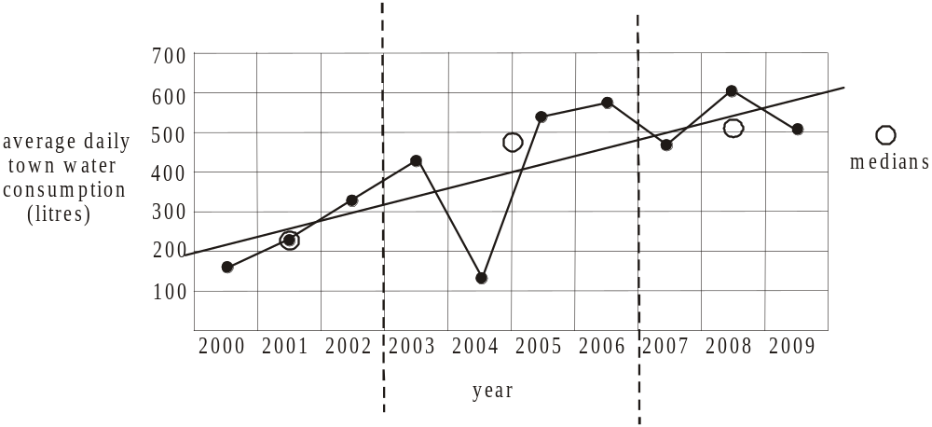

(1 mark) correct points circled
(1 mark) correct line

- Extend the 3 - median line on the time series plot and extend the horizontal axis as shown below to find the prediction for 2010 which is approximately 620L.
(1 mark)

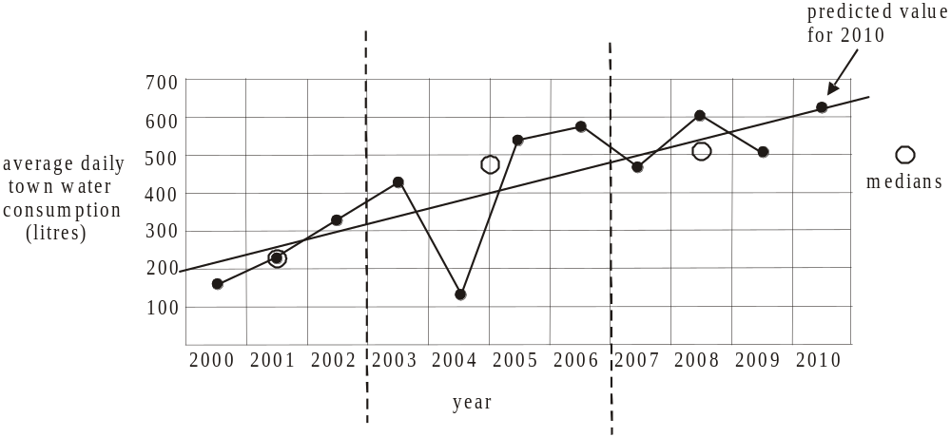

Question 4

- Since, rainfall then on average, for every 1mm increase in rainfall there is a decrease of 0.18kL of town water consumption in this household.
(1 mark)

- Since 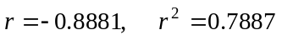 (to 4 decimal places).
(1 mark)

- The coefficient of determination tells us that 78.87% of the variation that occurs in town water consumption can be explained by the variation in rainfall.
(1 mark)

Question 5

- The relationship between the variables tank capacity and town water consumption is not linear.
(1 mark)

(1 mark) for 21.68
(1 mark) for – 0.03

Total 15 marks
SECTION B

Module 1: Number patterns

Question 1

- Method 1
Generate the sequence on your calculator. The twelfth row has 51 vines planted.
(1 mark)

Method 2
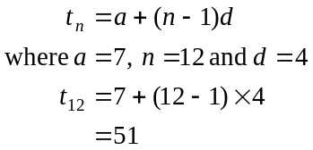
(1 mark)

- 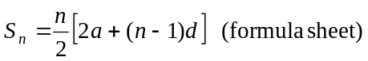
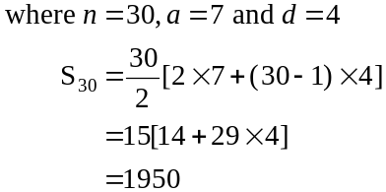
(1 mark)

- Method 1
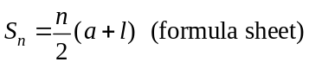
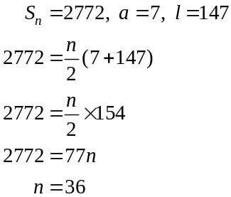
There are 36 rows.
(1 mark)
Method 2
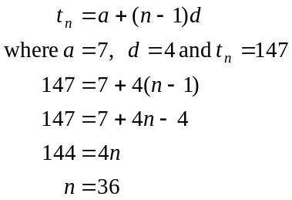
There are 36 rows. (1 mark)

Question 2

- Method 1
Generate the sequence on a calculator.
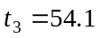(correct to 1 decimal place)
(1 mark)
Method 2
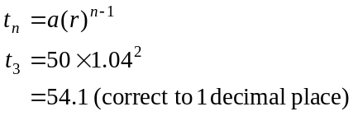
(1 mark)
- Since , the percentage increase each year is 4%.
(1 mark)
- Generate the sequence on your calculator. The harvest will first exceed 100 tonnes in the 19th year.
(1 mark)
- 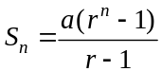
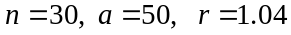
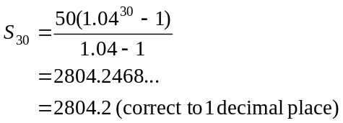
(1 mark)
- 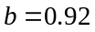 since the production is reduced by 8% of the previous year’s production; that is, it is only 92% of the previous year’s production.
(1 mark)
represents the production of Shiraz grapes in the 30th year.

Method 1
Generate the geometric sequence described at the start of Question 2. The thirtieth term is 155.9 (correct to 1decimal place). So 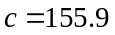 (correct to 1 decimal place).
(1 mark)
Method 2
From the start of Question 2, the geometric sequence is given by
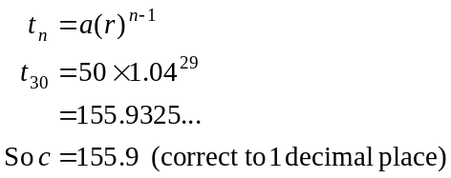
(1 mark)
f. The difference equation describes a geometric sequence so 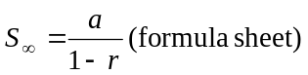
Now,. So the harvest in the first year of this period of decline is 143.428 tonnes
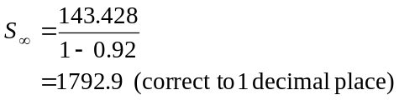
So 1792.9 tonnes would be produced.
(1 mark)
Question 3

- We require 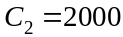
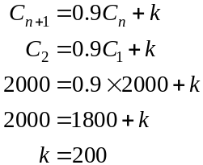
(1 mark)

- If ,
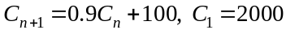
Method 1
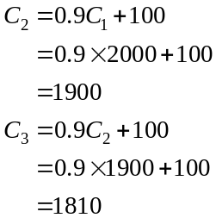
(1 mark)
Method 2
Generate the sequence on your calculator 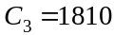.
(1 mark)
- If the sequence is geometric
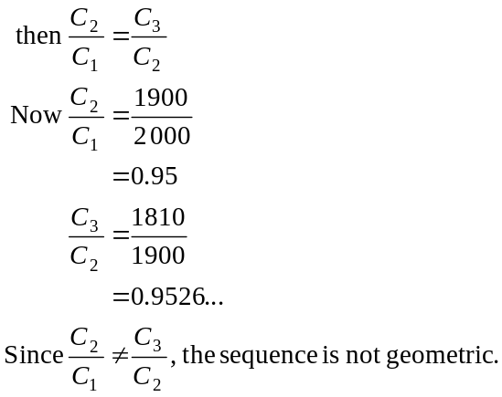
(1 mark)
- Generate the sequence generated by the difference equation .
Over the long term, specifically as n get up around 117 the value of 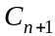 remains on 1000.
This is because if 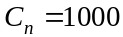,
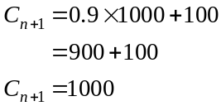
(1 mark)
Consequently the number of vines will always remain viable; that is, will always remain above 800.
(1 mark)
Total 15 marks

Module 2: Geometry and trigonometry

Question 1

- In ,
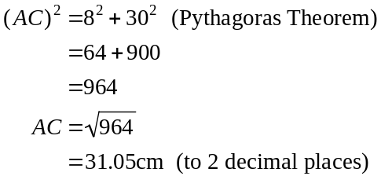
(1 mark)

- In ,
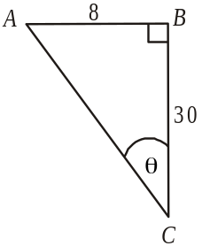
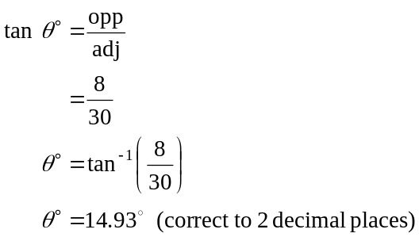
(1 mark)

- The rain water and the rain gauge have similar shapes. The scale factor is 10:30 or 1:3.
(1 mark)

So, the ratio of the volume of the rain water to the volume of the rain gauge is 1:3² or 1:9.
Note that we square the 3 rather than cube it because the areas of the cross-section are changing but the length; l, is not.
So the fraction of the rain gauge taken up by rain water was . (1 mark)

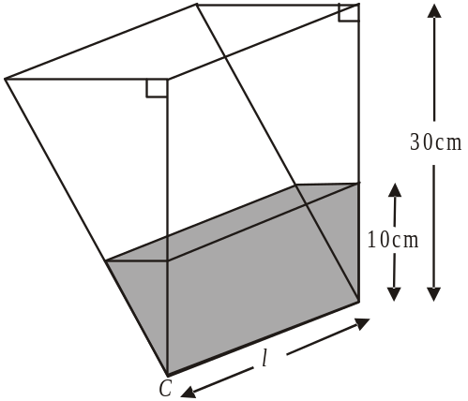

Question 2

- Heron’s formula (from formula sheet)
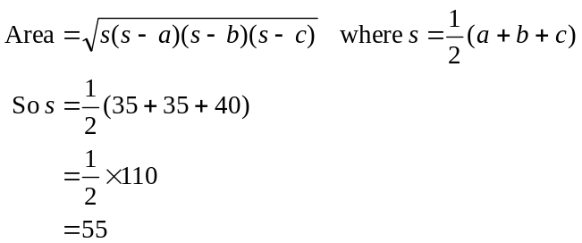
(1 mark)
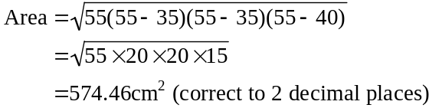
(1 mark)

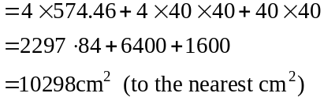
(1 mark)

- Method 1
Let M be the centre of the
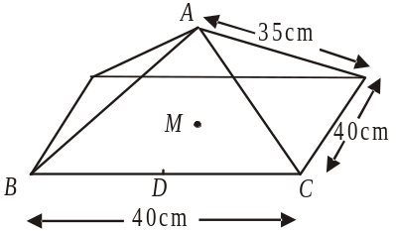
square base and let
D be the midpoint of BC.

In 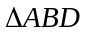
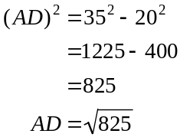
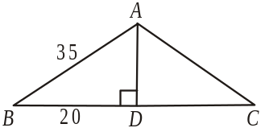

(1 mark)
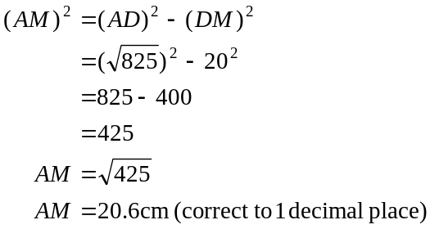
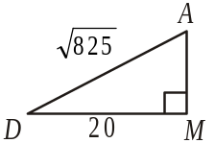
So the height of the pyramid is 20.6cm (correct to 1 decimal place).
(1 mark)
Method 2
Let M be the centre of the
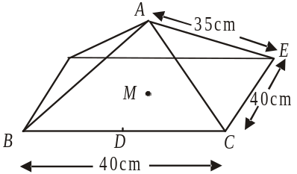
square base and let
D be the midpoint of BC.
In 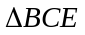
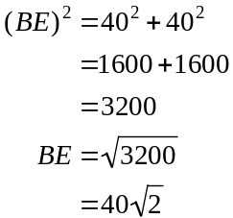
Since M is the midpoint of BE,
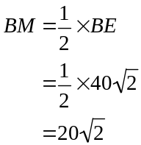
(1 mark)

In
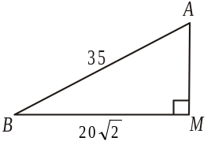
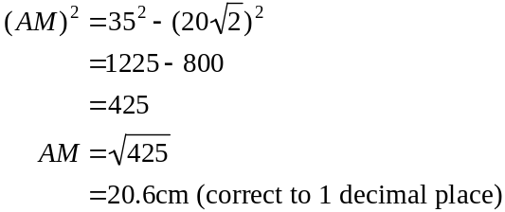
So the height of the pyramid is 20.6cm (correct to 1 decimal place).
(1 mark)

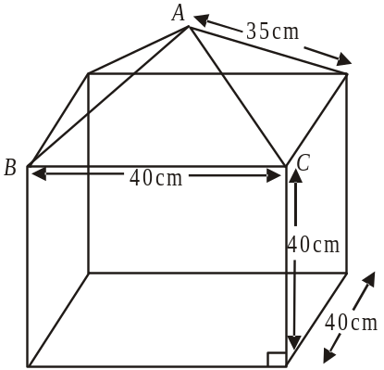
- volume of square prism base
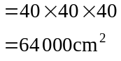

volume of square pyramid cover
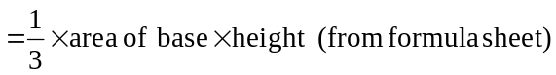
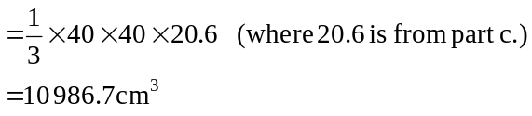

(1 mark)

Question 3
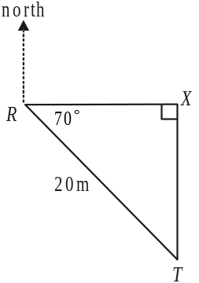
- In ,
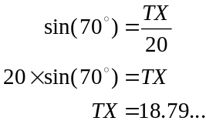
The tree is 18.8m (correct to 1 decimal place)
due south of the rain gauge.

(1 mark)

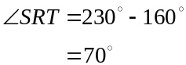

(1 mark)

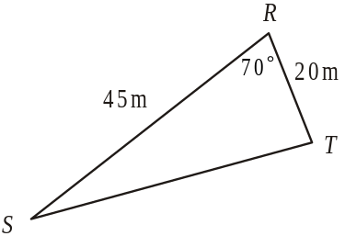
- In ,
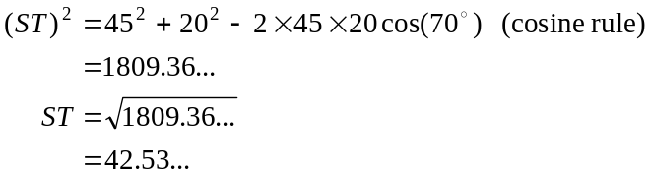
The distance ST is 42.5m (correct to 1 decimal place).

(1 mark)

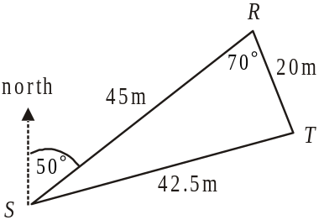
- In ,
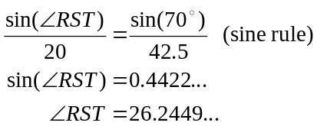

(1 mark)

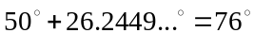 (to the nearest degree).
So the bearing of T from S is 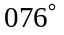.
(1 mark)
Total 15 marks

Module 3: Graphs and relations.

Question 1

- From the graph, Mick had earned $40 by 9am.
(1 mark)

- Mick was not being paid between 9am – 10am and between 12 noon and 1pm. In total he was not being paid for 2 hours.
(1 mark)

- Mick’s pay per hour for driving is 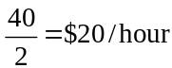.
(1 mark)
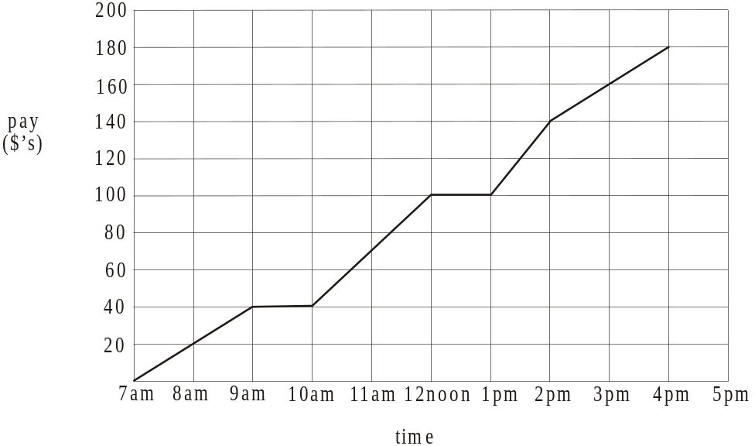

(1 mark)

- Look at the gradient of each of the line segments.
For driving, the hourly pay rate = $20/hour.
For unloading, the hourly pay rate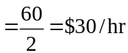.
For setting up, the hourly pay rate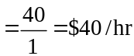.
For cleaning up, the hourly pay rate = $20/hour.
So setting up earns Mick’s the highest hourly rate of pay.
(1 mark) for correct answer and hourly rate for each task

Question 2

t (days) | 0 | 2 | 3 | 5
t³ (days³) | 0 | 8 | 27 | 125
F (dollars) | 0 | 96 | 324 | 1500

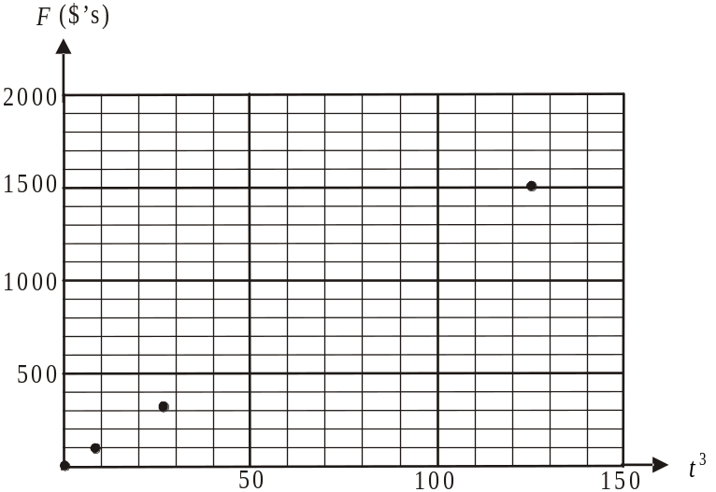

(1 mark) for correct entry in table and correct plotted point

- From the graph, the points lie along a straight line, the gradient of which is k. Choose any two points. For example 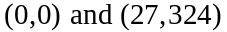.
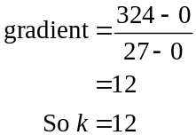
(1 mark)

- 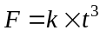
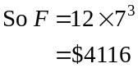
(1 mark)

- When a sound system is 3 days late the fine is $324. When a sound system is 4 days late the fine is given by
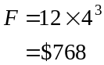
So the sound system must have been a minimum of 4 days late.
(1 mark)
Question 3

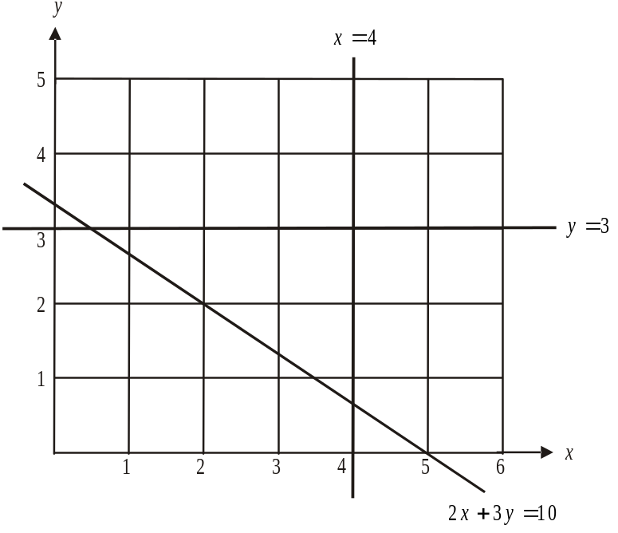

(1 mark)

- We are looking for integer values; that is, whole numbers representing the number of small and large trucks.
In the feasible region of the graph, which is shaded, there are 13 points that satisfy the constraints.
(1 mark)
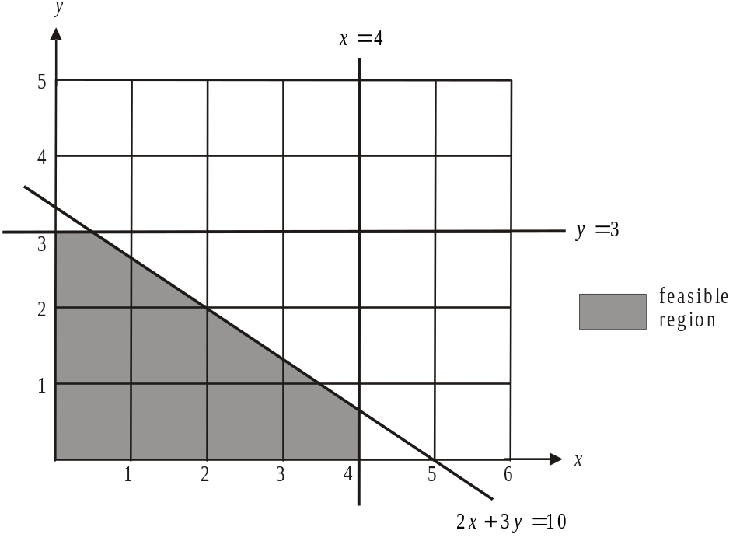

Note that the feasible points are:.
c. Objective function is 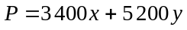. (1 mark)
From part b., the profit made could be:
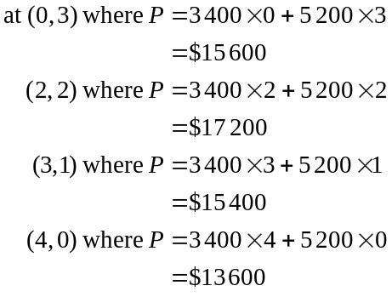
So the maximum profit is $17 200. (1 mark)
Note that in this case the maximum profit won’t necessarily occur at a corner point because the value of x and of y must be an integer (whole number) because we are talking about a number of trucks.
For example the points 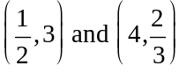 are corner points of the feasible region but because both the x and y values are NOT integers, they cannot represent a feasible number of trucks. So even though mathematically at 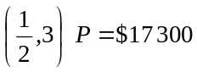, which gives maximum profit, the answer is unrealistic because you can’t have half a truck driving around!
Note also that it is not necessary to calculate the value of P for all 13 feasible points since clearly the value of P at 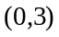 will be greater than at (0,0), (0,1) or (0,2).
d. The constraint imposed by the fuel shortage is 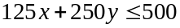 (1 mark)
Sketch the line 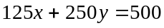 on the graph.
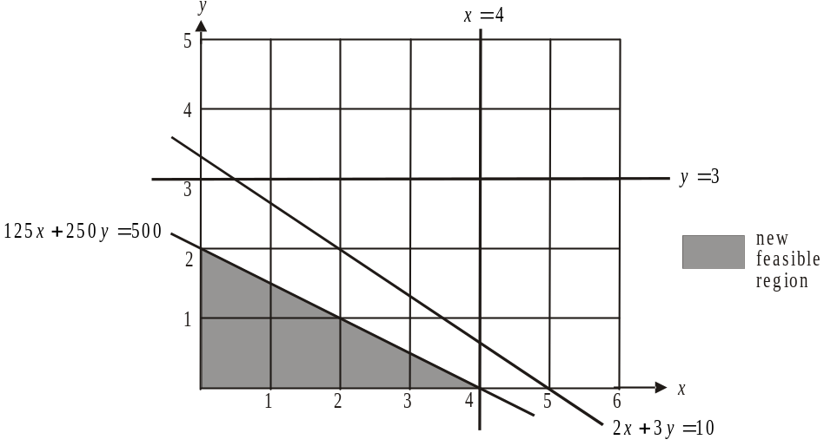

The new feasible region contains the points 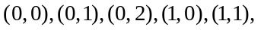 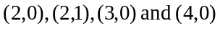. Also, from part c., 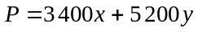.
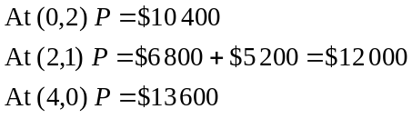
To maximize profit the company should send out 4 small trucks and no large trucks.
(1 mark)
Total 15 marks
Module 4: Business-related mathematics

Question 1

- 5% of 1400
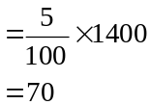
Discount is $70.
(1 mark)

- 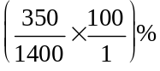
=25%
(1 mark)

- 0.5% of 1400
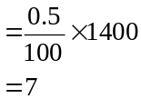
You would pay $1407.
(1 mark)

Question 2

- Remo pays 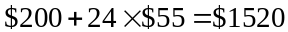 in total.
This represents 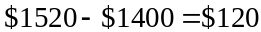 in interest.
(1 mark)

- Over 2 years he pays $120 in interest.
Over 1 year he pays $60 in interest.
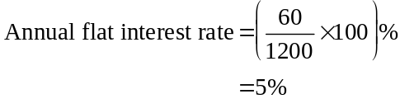
(1 mark)
Question 3

- i. 6% of 15 000
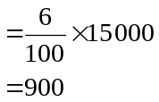
After one year the office equipment is valued at $14 100.
(1 mark)
- After 5 years the office equipment is valued at
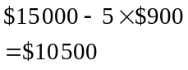
(1 mark)
    - At the end of the third year after purchase the value of the office equipment is given by
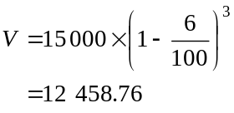
At the end of the fourth year the value is given by
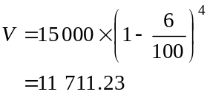
So during the fourth year the office equipment depreciates by 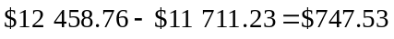.
(1 mark) for finding the value at the end of the third or fourth year
(1 mark) correct answer
Question 4

- Compound interest.
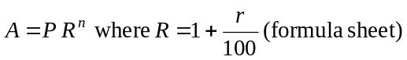
10.4% per annum is 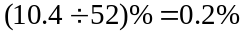 per week
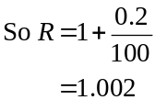
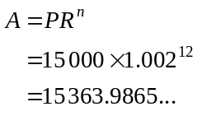
Required amount is $15 363.99.
(1 mark) correct method
(1 mark) correct answer
- From a., using the formula 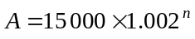 use trial and error for values of n until A first exceeds 15500.
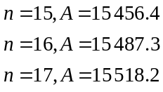
After 17 weeks the amount of interest first exceeds $500.
(1 mark)
Question 5

- Using TVM
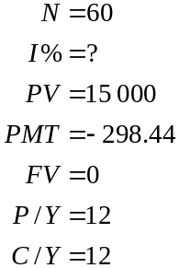
(correct to 1 decimal place).
(1 mark)

- At the end of 2 years, the amount still owing can found using TVM.
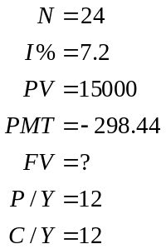
After 2 years, $9 636.59 is still owing.
(1 mark)

Using TVM again.
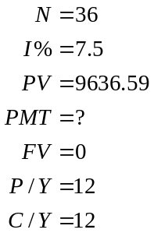
If the loan is to be paid out in 5 years, this is 3 years (i.e. 36 months) after the interest rate changes to 7.5%.
The new payment per month will be $299.76 so Remo’s payments increase by just
$299.76 - $298.44 = $1.32 per month.

(1 mark)
Total 15 marks
Module 5: Networks and decision mathematics

Question 1
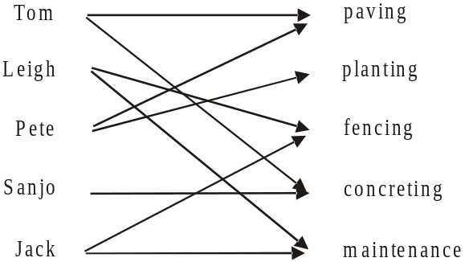

- Since Sanjo must be put in charge of concreting (he has no other expertise), Tom must be put in charge of paving.
(1 mark)
- From a., Sanjo can only be put in charge of concreting, so Tom can only be put in charge of paving, so Pete can only be put in charge of planting. Leigh and Jack can each be put in charge of fencing or maintenance. So three areas have only one person who can feasibly be put in charge.
(1 mark)

Question 2
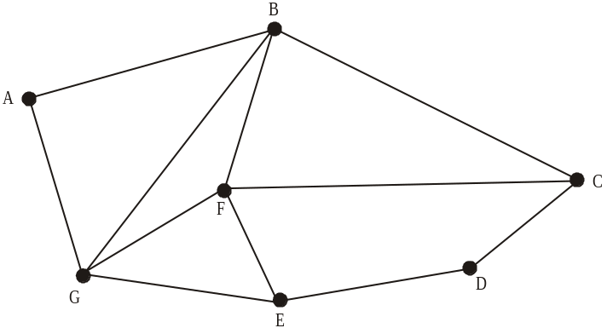

- The sum of the degrees of the vertices is
(1 mark)
- There are many possibilities.
For example:
A B C D E F G
A B C D E G F
A G E D C B F
A G E D C F B
A G F E D C B
and so on.
Each vertex must be visited only once.
(1 mark)
- The route Leigh plans is an Euler path, where each edge is travelled along just once.
He must start from an edge with an odd degree to enable this so he can start from vertex C or E.
(1 mark)
Question 3

- 1
(1 mark)

Player | Total of one-step dominance
Tom | 1
Leigh | 2
Pete | 3
Sanjo | 3
Jack | 1
Pete and Sanjo have equal highest totals.
(1 mark)

Player | Total of two-step dominance | Total of one-step and two-step dominance
Tom | 2
Leigh | 4
Pete | 4
Sanjo | 5
Jack | 1
The most dominant golfer is Sanjo. (1 mark)
The least dominant golfer is Jack. (1 mark)

Question 4

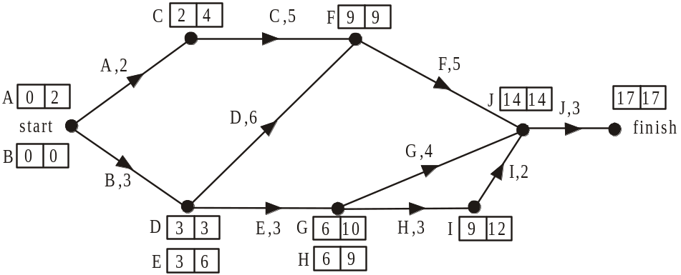

The earliest start time and the latest start time are shown respectively for each activity on the network above.

- The earliest start time for activity F is 9 days.
(1 mark)

- The latest start time for activity H is 9 days.
(1 mark)

- The minimum time that the job can be completed in is 17 days.
(1 mark)
d. Removing activity D reduces the completion time by 2 days.

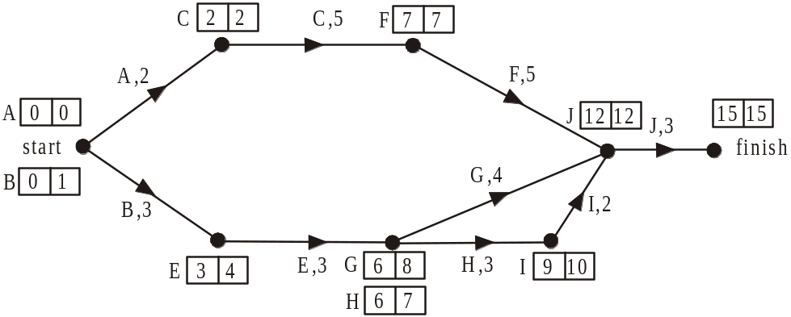

(1 mark)

e. Activities A, C, F and J are on the critical path.
Activity J can be reduced by 2 days to the minimum of 1 day. Since activity J is not a predecessor of any other activities, no other activities become critical as a result of reducing it.
The job will now take 13 days.

Activity F can be reduced by 1 day and the job now takes 12 days.

This also places activities B, E, H and I on the critical path.
Reducing activity F by 1 further day and reducing activity H by 1 day reduces the job now to 11 days.

This now places activity G on the critical path.
Reducing activity F by yet a further day, activity H by 1 further day and activity G by 1 day will reduce the job to 10 days as required.

In summary:
Activity | Number of days to be reduced
F | 3
G | 1
H | 2
J | 2

(1 mark) 2 correct totals
(1 mark) 2 more correct totals

Total 15 marks

Module 6: Matrices

Question 1

- .
(1 mark)

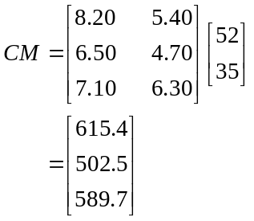

(1 mark)

- The cost of purchasing the oil used last month from wholesaler Y would have been $502.50.
(1 mark)

Question 2

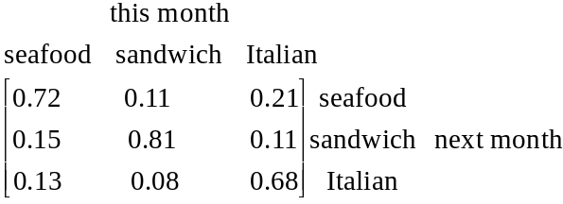

(1 mark)
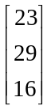
- i.

(1 mark)
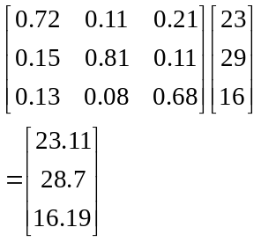

So the number of seafood boardroom lunches expected this month is 23.

(1 mark)
Question 3
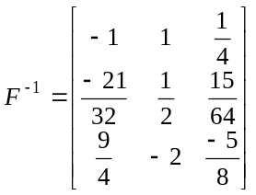

(1 mark)

- Total amount paid to the staff working at the 21st was $605.
(1 mark)
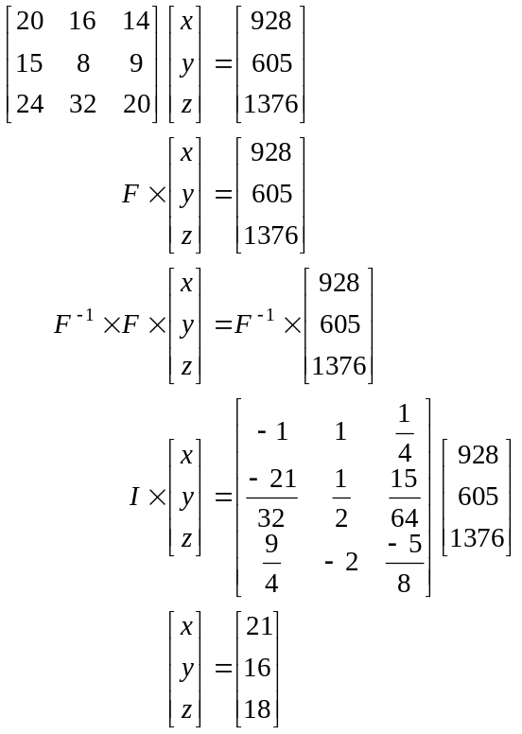

The hourly rate paid to kitchen staff is $18 per hour.
(1 mark)
(Note: not all lines shown above need to be shown. They are shown here to explain the process.)

Question 4

- number of regular clients
(1 mark)
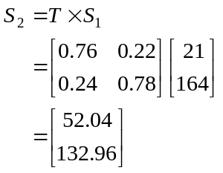
- i.

So in the second year, 52 regular clients pay electronically.
(1 mark)
  - Try
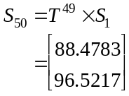

Try
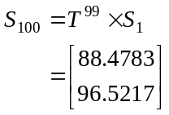
(1 mark)
Since there is no change between and we can assume that a steady state has been reached.
So in the long term, 88 regular clients will pay electronically.
(1 mark)
- i. 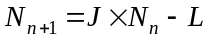
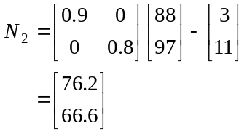
So 76 regular clients paid electronically during the second year of the new ownership.
(1 mark)
ii.
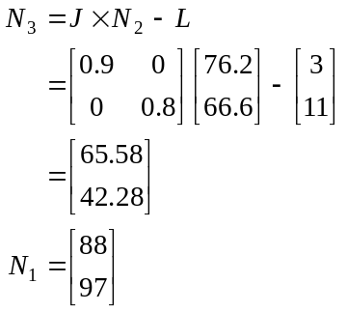

In the first year of the new ownership there were regular clients. In the third year there were or 108 regular clients. So, 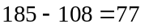 regular clients were lost.
(1 mark)
Total 15 marks

